Web site address www.tearsofjoycanada.com E-mail address tearsofjoycanada@gmail.com
Tears of Joy Canada
NEWSLETTER
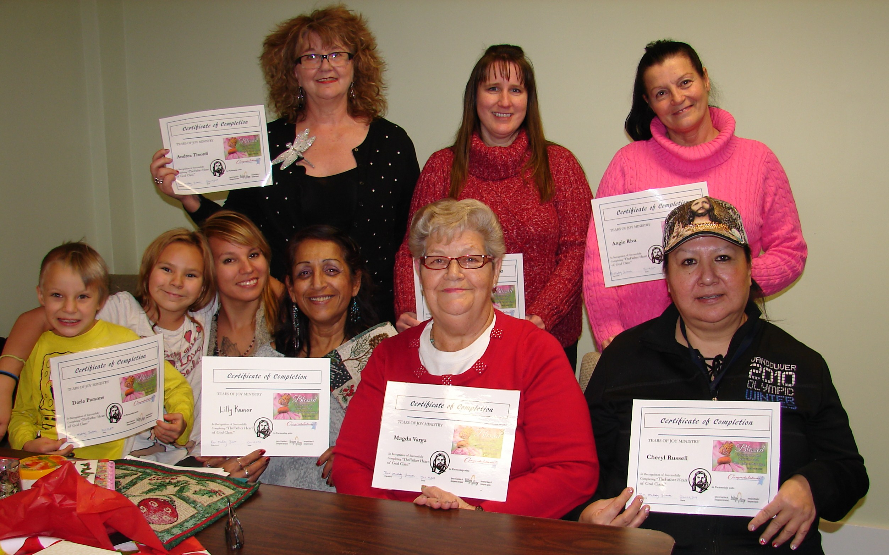

This last fall I taught two women’s classes called “Forgiveness and Acceptance” and “The Father Heart of God.” I just finished teaching a class called “Taking Every Thought Captive.” There were 10-12 ladies who came out to these classes and they received a lot of inner healing as the truth was revealed to them about who they are and who God is. We also started personal ministry to walk the some of the ladies through steps of forgiveness and release. Please pray that they will apply these steps to their live and pray for covering and protection for me and my prayer partner as we continue
do more personal ministry this winter 2015.

English as a Second

Language

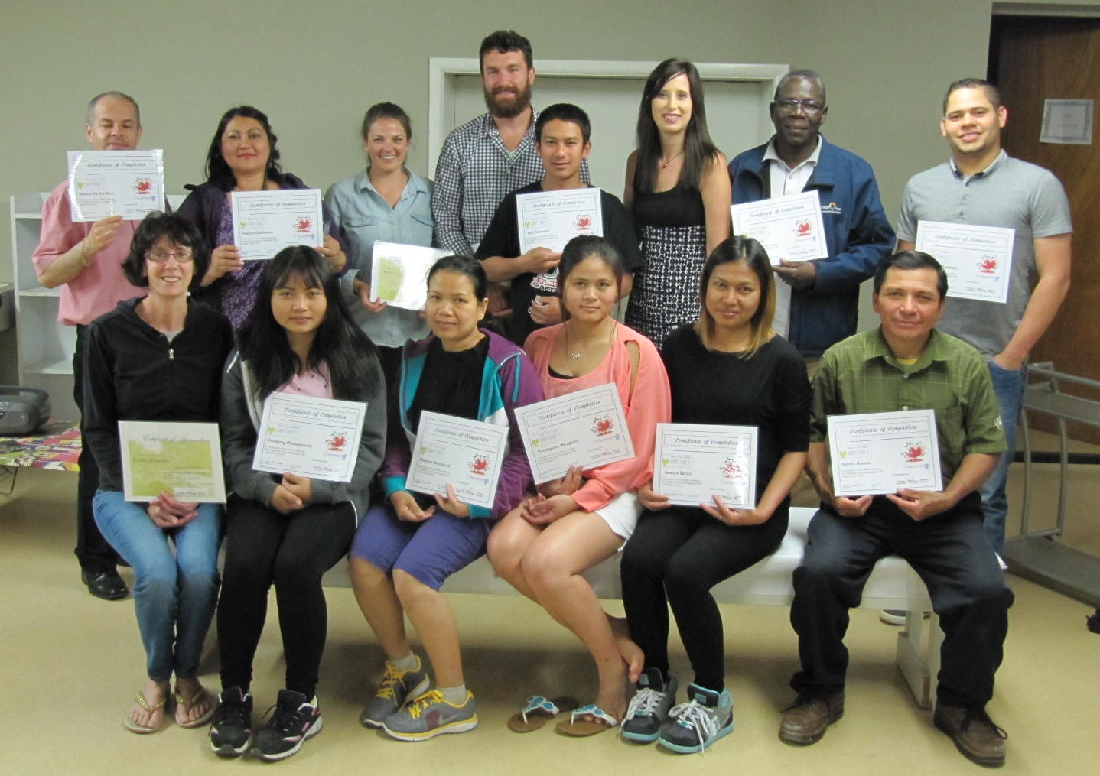

Women’s Classes

Upcoming Mission Trips
We are planning a mission trip this spring to the Dominican Republic and Haitian Villages again. If you can donate to this cause or help send school supplies, and small toys or clothes we can make sure it gets into the right hands. We are all in this together and you can make a big difference in the people’s lives through prayer and support.
The last E.S.L. Class went really well. There were some more students who came out from Thailand again and we were able to work with them and minister to some of their needs. We are planning a new semester for teaching English to the immigrants in the community this coming Feb. 2015. Please pray for the students since most of them are still trying to get their families here and have been separated for a number of years from loved ones. As well pray for health and wisdom for the teachers as we work with the students.

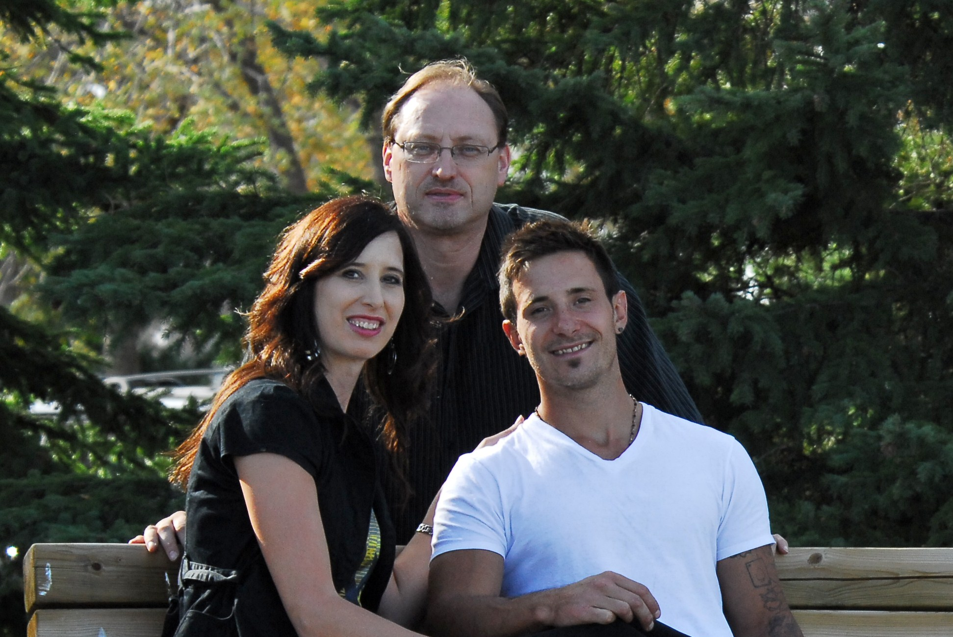

January 2015

By Melody Friesen

Dominican Republic 2015
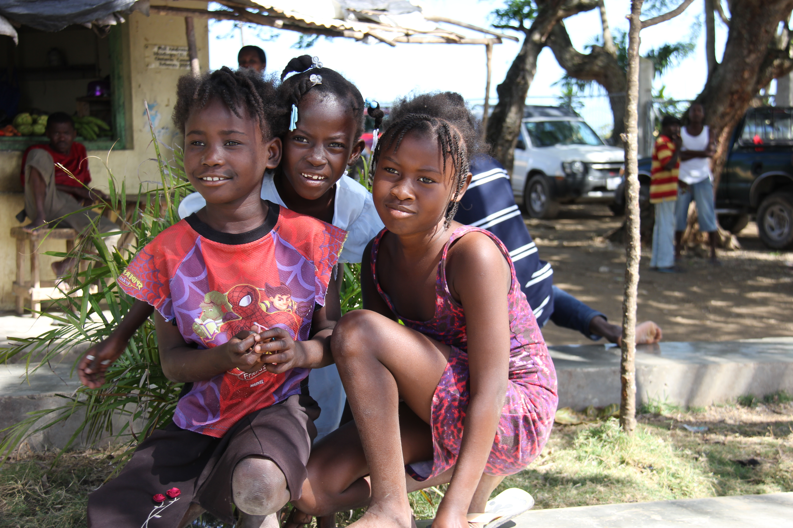

Melody, Lew and Kaleb Friesen

Field trips this past summer
Tears of Joy Ministry Canada/International could not exist without the help and support of different organizations and people like you. We want to take this time to offer our thanks and appreciation for your continued prayers and support and also to wish you many blessings and health and strength to you and your family in this New Year.

Thanks for all you do!
Love from, Lew and Melody Friesen
A few students with the T-Rex at the Milk River Museum summer 2015
May God Bless you and Keep you and we hope to hear from you soon! If you are interested in giving a financial donation so some of the upcoming projects you will receive a tax deductible receipt.
To Restore, To Renew and Rebuild People!
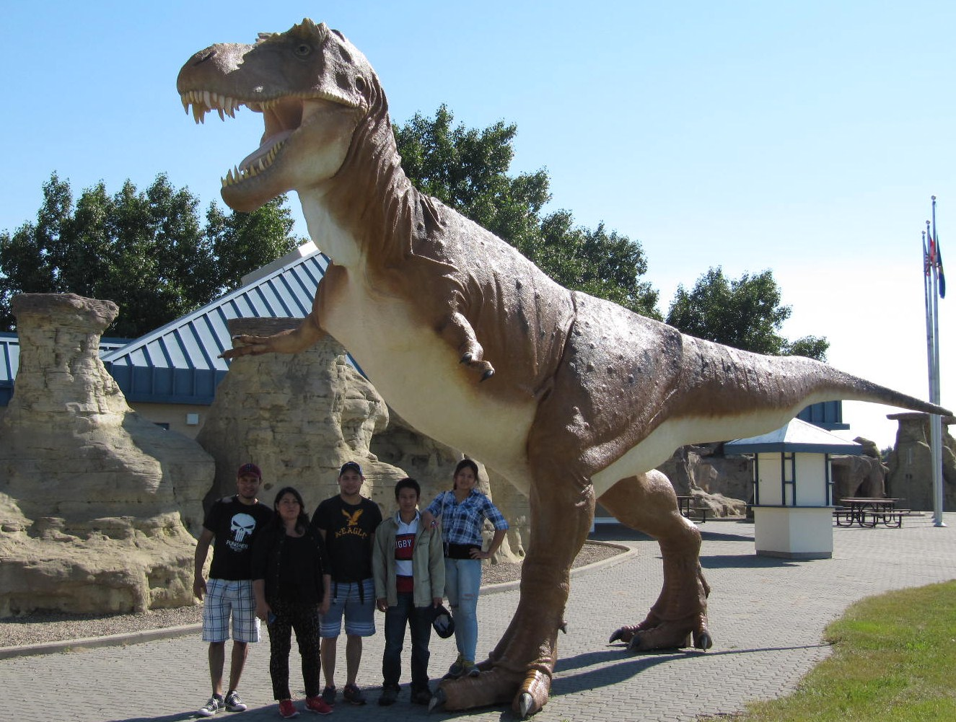


We took some of the ESL Students to a museum in Milk River AB. this past summer and then we also went down to Writing on Stone Provincial Park with them for the day.
We had a fun time just relaxing in the sun and enjoying time on the “Hoo Doos” and seeing the sights in Southern Alberta. Then we all brought some snacks and shared a late lunch together before heading back to Lethbridge. A lot of the immigrants work so much they don’t often enjoy a day off from work so this was a real treat for them.

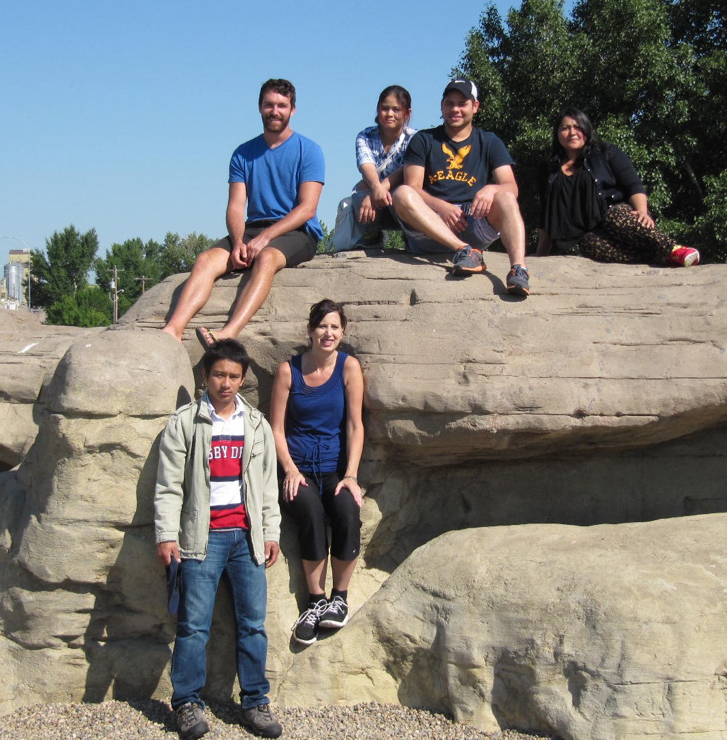
“Tears of Joy will stream down their faces and I will lead them home with great care.
The young women will dance for joy, and the men-old and young will join in the celebration. I will turn their mourning into joy. I will comfort them and exchange their sorrow for rejoicing.”
Jeremiah 31:9&13
(N.L.T.)

